[Blog Post 1 - Research Title]

Designing an improved passport renewal process with   
the government of Mexico

[Image relevant to post]

When the Mexican government sought to design a new experience to help citizens renew their passports, they connected with the [University of Washington’s Human Centered Design and Engineering program](https://www.hcde.washington.edu/). When our team joined the effort, the government had prototyped a simple bot that could schedule in-person appointments for passport renewal, but they wanted to understand how they could use the bot to make the entire passport renewal process more efficient and seamless. To that end, our team decided to apply a human-centered design approach to conduct research about users and make design recommendations to refine the existing bot experience.

This is the first of two posts where we’ll examine how our research team investigated people’s experiences of renewing their Mexican passports, applied cultural theory to understand what design affordances would be a good fit for this culture, came up with design directions to address pain points and ultimately decided upon a single design approach that would help the Mexican government better serve the needs of its citizens.

# What cultural theory says

[Hofstede’s cultural theory](https://www.hofstede-insights.com/country-comparison/mexico,the-usa/) offered some valuable insights for our team regarding what design affordances might make sense for this experience. (Please refer to Table 1 at the end of this section for Mexico’s Hofstede scores compared against those of the United States and Canada).

First, Mexico’s high power distance and low long-term orientation scores indicate an established hierarchy and system of rules that is not often questioned. This could mean, for example, that many people trust the government with their information or personal data, and respect governmental requirements. You can see this hypothesis reinforced by our findings below.

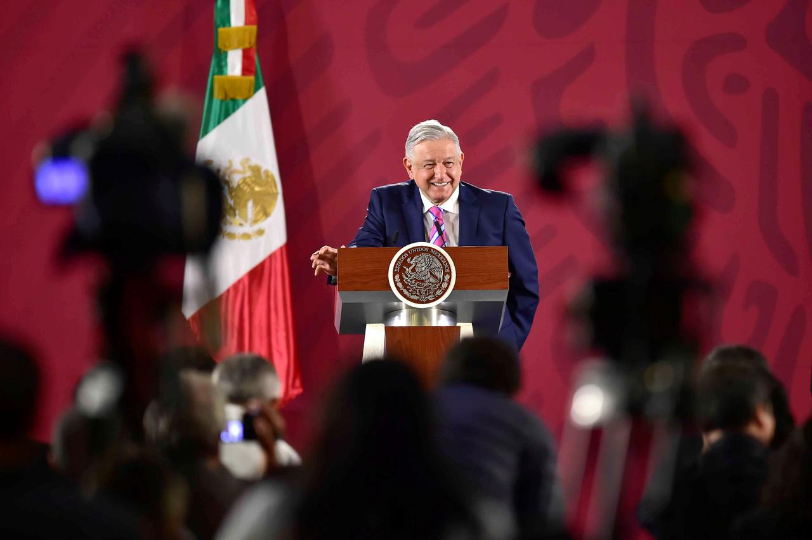

According to Hoftede’s model, Mexico also has a low score on individualism, meaning the culture prizes relationships, especially those of family or extended family groups. Because of this, pursuing a supportive, personal, and conversational experience like the one the government had envisioned seemed like a good way to improve the relationship between the government and its citizens. Our research reflects this as well.

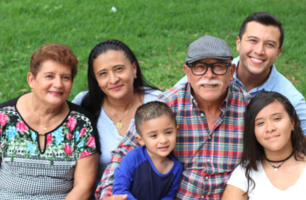

Mexico also scores high on masculinity, meaning that it's a work-driven society that values decisiveness and assertiveness. This, combined with Mexico’s high uncertainty avoidance score, might indicate that citizens would be frustrated with a process that lacks clarity and an unsure outcome. You can find more detail on this in our findings below.

There are two other important cultural theories that impact design: high vs. low context communication and polychronic versus monochronic. Mexico is both high context and polychronic, meaning that personalization is important and that people may prefer to multitask as opposed to focus on one thing at a time. In our next post, you’ll see that our recommended design approach ultimately blends a conversational and web experience into one interaction that feels guided, informative, and friendly.

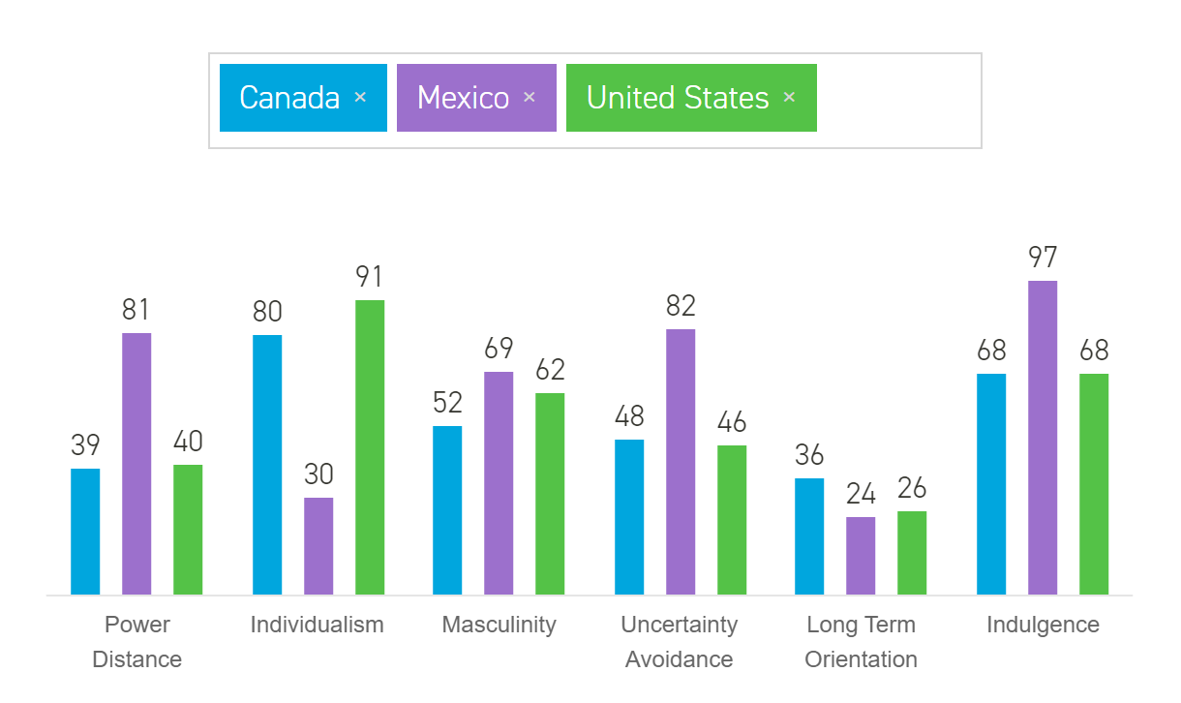

Table 1: Hofstede scores of United States, Mexico and Canada

# Methods

## Human-Centered Design

Our project was guided by Human-Centered Design principles.

*Human-centered design is an approach to developing products, services, and interactive systems that are focused on user needs. It involves deeply getting to know the people who will use the design: how they think, how they’ll feel when they’re using it, and what they’re trying to achieve. It’s typically made up of six stages.*

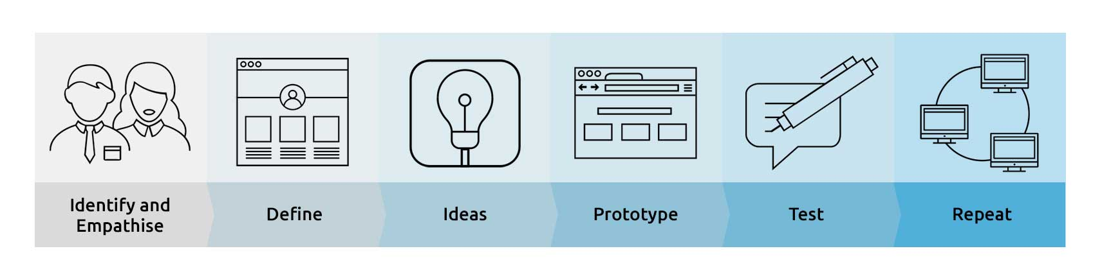

<https://www.internetrix.com.au/blog/see-your-site-improve-by-following-this-user-centered-design-process/>

Before coming up with design concepts, we gathered insights from real people through qualitative research. We chose a semi-structured interview method as it allows for more open-ended responses while retaining some planning, which allowed us to gather more in-depth information on the participants’ experiences with passport renewal in Mexico.

The interviews were conducted remotely via Zoom, and each lasted around one hour. A moderator led each session -- assisting, probing, and debriefing the participant while a notetaker would take notes and keep track of time. The participants were first invited to share background information about themselves, and then guided through an open discussion on topics such as their last passport renewal experience, their evaluations of the process, and their thoughts on virtual assistants and chatbots.

## Participant Profile

A total of five interview participants were recruited through snowball sampling considering time and resource constraints. Below is a table of our participants’ profiles (with fictitious names and avatars for privacy protection).

|  |  |  |  |  |  |
| --- | --- | --- | --- | --- | --- |
|  | **P1** | **P2** | **P3** | **P4** | **P5** |
| **Gender** | Female | Male | Male | Female | Male |
| **Occupation** | PhD Candidate at UNAM | Software Engineer | College Student at UNAM | Industrial Designer | Market Research at a Government Agency |
| **Language of Interview** | Spanish | English | Spanish | English | Spanish |
| **Citizenship** | Mexican Citizenship | Mexican Citizenship | Mexican Citizenship | Mexican Citizenship & Permanent Residency in Germany | Mexican & Spanish Dual Citizenship |
| **Place of Residence** | Oaxaca & Mexico City | Mexico City | North of Mexico City | Berlin | Mexico City |
| **Previous experience with passport application** | Applied for passport for her son, as well as renewed passport for herself and her daughter last year | Renewed his passport last November because he needed a new US tourist visa | Applied for his passport because he would like to travel to other countries at some point | Renewed her passport 8 years ago as she needed it for travels | Renewed his passport because he had a trip to the US |

# Data analysis

## Data Familiarization and Open Codes

We collected qualitative interview data in two languages (Spanish and English) from our five participants. To familiarize ourselves with the data, Antonio (native Spanish speaker of the team) translated the Spanish transcript into English so that the English speakers of the team could interpret the interview data. Through a thorough review of the text and audio recordings, we created sticky notes of the raw data from each participant by extracting a series of thoughts, suggestions, and feelings from their answers to the interview questions. An example of the transcript analysis looks like:

|  |  |
| --- | --- |
| **Interview Extract** | **Open Codes** |
| Participant: Also, I would like the virtual assistant to ask me since the beginning of the conversation how to address me such as by simply my name or by “Mr. Enrique.” I would like to feel that the virtual assistant is capable of adapting to mewith courtesy**.** I don’t want to feel that I have to adapt to the machine. | User chooses how they’d like to be addressed by the bot;  Personalized service;  Courteous manner |

Alternative：

## Affinity Diagram

Next, we did an affinity diagram, where we generated open codes by grouping together the sticky notes with similar themes. Here’s a screenshot of part of the diagram (you can view the full version here).

<https://app.lucidchart.com/documents/view/188a06a1-3074-4665-b447-b7fbaeea4722/0_0>

## Final Code Table

Finally, we created a total of nine axial codes by identifying the relationships between open codes based on preconceived themes informed by interview questions and inductive reasoning. We then summarized the key insights under each axial code. An example of part of the final code table is below.

|  |  |
| --- | --- |
| **Axial Code** | **Open Code** |
| **Existing pain points** | Hard to keep track of documents |
| Appointment process causes negative feelings |
| Demand for an empathetic, human-centered, personalized process |
| Pre-appointment logistics challenges |
| Edge case |
| **Expectations for the passport renewal process** | Straightforward, quick and relaxing |
| Virtual application and appointment |
| Access to phone channel |
| Documentation error check prior to appointment |
| Pick my own date and time |
| Appointment reminder |
| **Expectations for the bot’s functions** | Answer personalized questions |
| Validate documents |
| Easy workflow |
| Web & mobile platform availability (integration with Whatsapp) |
| CURP look-up |
| Reminders of appointment time, late policy and checklist |
| Voice interaction |
| **Expectations for the bot’s personality and user experience** | Friendly |
| Helpful |
| Conversational |
| Kind |
| Open-minded, inquisitive |
| Courteous/respectful |
| Clear |
| Informal address or user gets to choose how they’d like to be addressed |

Alternative:

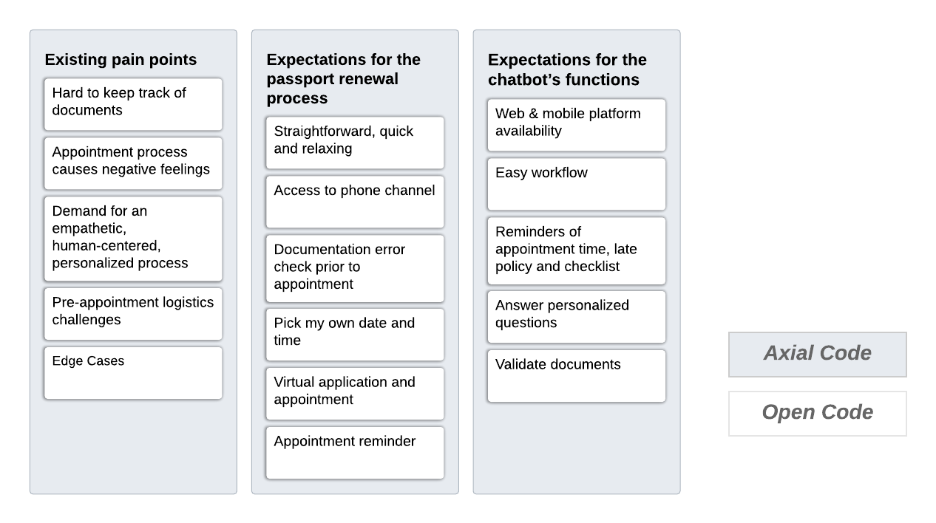

# Findings

* **Trust in authority**: Overall, 4/5 of the participants said they trusted the government with their personal information, and that they would not have any issues with supplying the bot with any personal information it requested.
* **What’s difficult about the current experience**: People were overwhelmed by documentation and wanted help keeping track of what documents were needed. The top pain point we identified was around errors in documentation. Participants said these errors were often identified over the course of several in-person visits, which made the passport renewal process frustrating, stressful, and inefficient. They also wanted humanized and empathetic personalization, since different documents may be required based on the individual’s circumstances.
* **Expectations of the passport renewal experience**: Because of the frustration around documentation, people wanted a way to check their documents beforehand to make sure they are complete and error-free. They also wanted to be able to book an appointment online, where they could pick the time and date of their appointment. However, they also wanted human support when needed. Some participants also noted that some people, such as seniors, may not want to use the bot at all. Once people arrived at their in-person appointment, they wanted to pick up their passports quickly. They also wanted reminders for those appointments beforehand.
* **Expectations of the bot’s functionalities**: People wanted to be able to access the bot on both web and mobile devices. Some participants specifically mentioned WhatsApp. People also wanted the bot to be able to answer questions based on their specific needs/situation, and to be able to look up their info, if possible.
* **Bot personality**: Participants want to interact with a bot that is friendly, courteous and respectful, helpful, conversational, kind, open-minded and inclusive, and clear. Most participants suggested that they would like the bot to address them informally, but at least one participant suggested that it could ask the user how they wanted to be addressed.

In terms of culture theory, Mexicans trust and follow the government authority since they accept that they are part of a hierarchical society. The high uncertainty avoidance in Mexican society manifests in the unwillingness of Mexican citizens to continue experiencing anxiety and ambiguity in the current passport application experience. People would rather avoid all uncertainty and be very clear as to what documentation is required or any prior procedures before going for a passport appointment. This means that passport application rules need to be set at the beginning of the process to avoid deviation and confusion. Mexico is considered a masculine society, suggesting that there is an underlying presence of desire for success, which manifests in the desire for Mexican citizens to succeed in application processes.

# Limitations

It was important to our team that we have cultural ambassadors and interviewed participants from many parts of Mexico. Due to the complex nature of passport application and renewal, given more time, we would have liked to recruit and interview more people.

While not completely flawless, there are elements of Hofstede's model that can be used to learn the fundamentals of a country’s values. However, one of the flaws of the Hofstede model is not incorporating multicultural backgrounds. There could have been generalizations from the model that did not account for indiginous populations. Furthermore, we did not have the opportunity to explore dual citizenship, which is a fairly complex process that is unique to each country involved. Lastly, due to resources and the pandemic, we did not have the opportunity to interview participants in person, which can provide environmental and contextual clues as to the interviewee's opinions and state of mind. This lack of environmental context limited some of our understanding of the process.

# References

* [Hofstede Insights](https://www.hofstede-insights.com/product/compare-countries/)
* Textbook/PDF on Hofstede from class reading
* [HCD/UCD](https://www.designkit.org/human-centered-design)
* [Mexican Government - Passport Process](https://www.gob.mx/pasaporte)